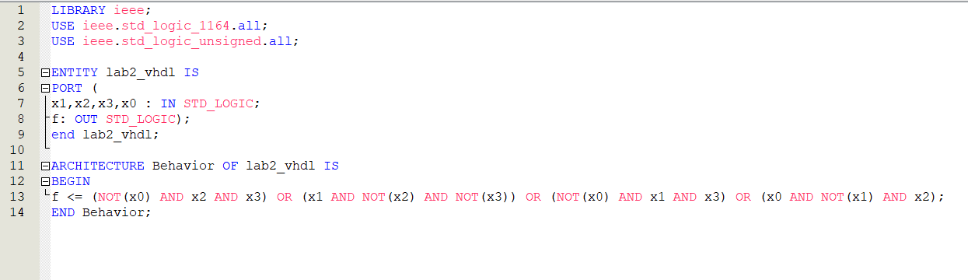

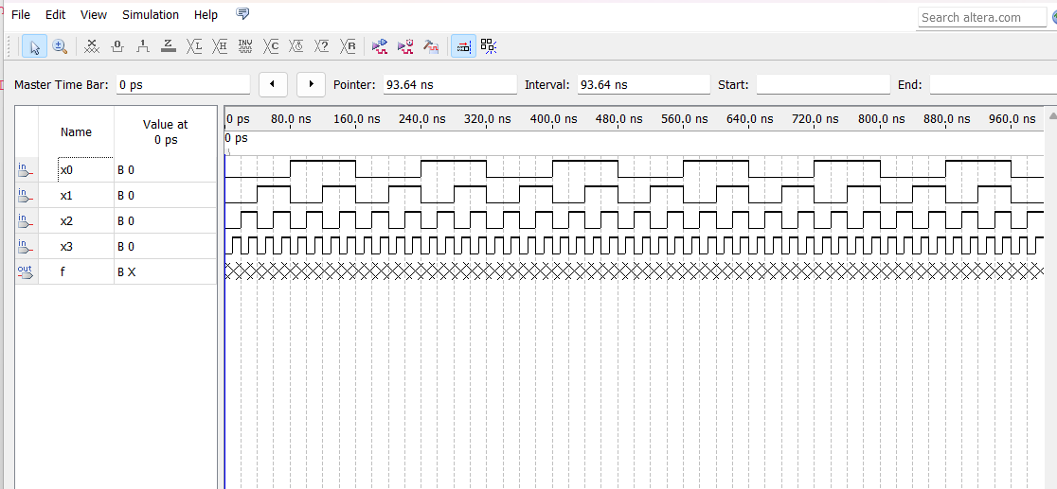

Conclusion:
In this lab I learned to implement logic function by using NAND gates and designed, built, and tested function using the Karnaugh map method. Using my last four digits of my student number I determine that I was designing function 1. Using the K-Map method, I figured out the complete function. Then I used VHDL to code that function to simulate a waveform result.

